Part 1 — Practical Questions with Hints
Question 1 — Basic Mocha and Chai Test
Write a Node.js program to create a simple Calculator module with add(), subtract(), and multiply() functions. Write a Mocha test suite using Chai assertions to test all three functions.
Hint:
- Create calculator.js.
- Export the three functions.
- Create test/calculator.test.js.
- Use describe() and it().
- Use Chai's expect() assertions.
CMD: npx mocha
CODE:
calculator.js
function add(a, b) {
return a + b;
}

function subtract(a, b) {
return a - b;
}

function multiply(a, b) {
return a * b;
}

module.exports = {
add,
subtract,
multiply
};

test/calculator.test.js
const { expect } = require("chai");
const calculator = require("../calculator");
describe("Calculator Functions", function () {
it("should add two numbers", function () {
expect(calculator.add(10, 5)).to.equal(15);
});
it("should subtract two numbers", function () {
expect(calculator.subtract(10, 5)).to.equal(5);
});
it("should multiply two numbers", function () {
expect(calculator.multiply(10, 5)).to.equal(50);
});
});

OUTPUT:
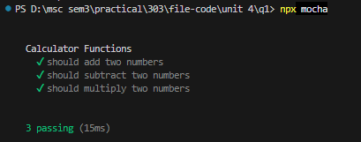
Question 2 — Testing Asynchronous Code
Write a Node.js program that contains an asynchronous function getUser() which returns user information after 1 second. Write Mocha and Chai tests to verify that the returned user has the expected name and ID.
Hint:
- Use setTimeout() inside getUser().
- Return a Promise.
- Use async/await in the Mocha test.
- Verify the result using expect().
CMD: npx mocha
CODE:
user.js
function getUser() {
return new Promise((resolve) => {
setTimeout(() => {
resolve({
id: 1,
name: "Shraddha"
});
}, 1000);
});
}

module.exports = getUser;

Test/user.test.js
const { expect } = require("chai");
const getUser = require("../user");
describe("getUser Async Function", function () {
it("should return the expected user", async function () {
const user = await getUser();
expect(user.id).to.equal(1);
expect(user.name).to.equal("Shraddha");
});
});
OUTPUT:
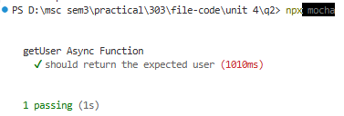
Question 3 — Testing an Express Application
Write an Express.js application having a GET /users route that returns a JSON array of users. Write a Mocha test using Chai and Supertest to verify that the route returns HTTP status 200 and the correct user data.
Hint:
- Install express, mocha, chai, and supertest.
- Create an Express application.
- Export the app instead of directly calling listen().
- Use request(app).get('/users').
- Check response.status and response.body.
CODE:
App.is
const express = require("express");
const app = express();
app.use(express.json());
const users = [
{ id: 1,name: "Shraddha"},
{id: 2,name: "Shrusti"}
];
app.get("/users", (req, res) => {
res.json(users);
});
module.exports = app;

Test/users.test.js
const { expect } = require("chai");
const request = require("supertest");
const app = require("../app");
describe("GET /users", function () {
it("should return all users", async function () {
const response = await request(app).get("/users");
expect(response.status).to.equal(200);
expect(response.body).to.deep.equal([
{ id: 1, name: "Shraddha"},
{ id: 2, name: "Shrusti"}
]);
});
});

OUTPUT:
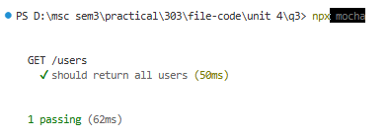
Question 4 — Setup and Teardown
Write a Node.js test program for a task application. Use Mocha's before(), after(), beforeEach(), and afterEach() hooks to create and clear test data before and after tests.
Hint:
- Create an array to act as a temporary database.
- Use before() for initial setup.
- Use beforeEach() to insert test data.
- Use afterEach() to clear data.
- Use after() for final cleanup.
CODE:
Task.js
let tasks = [];
function addTask(task) { tasks.push(task);}
function getTasks() { return tasks;}
function clearTasks() { tasks = []; }
module.exports = { addTask,getTasks,clearTasks};

Test/task.test.js
const { expect } = require("chai");
const { addTask,getTasks,clearTasks} = require("../task");

describe("Task Application - Setup and Teardown", function () {
// Runs once before all tests
before(function () {
clearTasks();
console.log("Initial setup completed");
});
// Runs before every test
beforeEach(function () {
addTask({
id: 1,
title: "Learn Mocha",
completed: false
});
});
// Runs after every test
afterEach(function () {
clearTasks();
});
// Runs once after all tests
after(function () {
clearTasks();
console.log("Final cleanup completed");
});
it("should add test data before each test", function () {
const tasks = getTasks();
expect(tasks).to.have.lengthOf(1);
expect(tasks[0].title).to.equal("Learn Mocha");
});
it("should contain incomplete task", function () {
const tasks = getTasks();
expect(tasks[0].completed).to.equal(false);
});

});

OUTPUT:
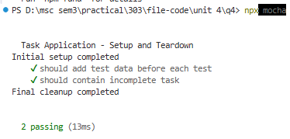
Question 5 — Testing with Authentication
Write an Express.js application with a protected GET /profile route. The route should return user information only when a valid authentication token is supplied. Write Mocha, Chai, and Supertest tests for both authenticated and unauthenticated requests.
Hint:
- Create authentication middleware.
- Check the Authorization header.
- Accept a token such as Bearer secret123.
- Test that a valid token returns 200.
- Test that an invalid/missing token returns 401.
CODE:
App.js
const express = require("express");
const app = express();
app.use(express.json());
// Authentication Middleware
function authenticate(req, res, next) {
const authHeader = req.headers.authorization;
if (authHeader !== "Bearer secret123") {
return res.status(401).json({
message: "Unauthorized"
});
}
next();
}
// Protected Profile Route
app.get("/profile", authenticate, (req, res) => {
res.json({
id: 1,
name: "Shraddha",
role: "Student"
});
});
module.exports = app;

test/profile.app.js
const { expect } = require("chai");
const request = require("supertest");
const app = require("../app");
describe("GET /profile Authentication", function () {
it("should return profile for a valid token", async function () {
const response = await request(app)
.get("/profile")
.set("Authorization", "Bearer secret123");
expect(response.status).to.equal(200);
expect(response.body).to.deep.equal({
id: 1,
name: "Shraddha",
role: "Student"
});
});
it("should return 401 for an invalid token", async function () {
const response = await request(app)
.get("/profile")
.set("Authorization", "Bearer wrongtoken");
expect(response.status).to.equal(401);
expect(response.body.message).to.equal("Unauthorized");
});
});

OUTPUT:
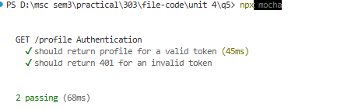

Question 6 — Mocking a Function with Sinon
Write a Node.js program containing a UserService that calls an external email service when a user registers. Use Sinon to mock/stub the email service and write a Mocha test to verify that the email service was called without actually sending an email.
Hint:
- Create emailService.sendEmail().
- Create userService.registerUser().
- Use sinon.stub() to replace sendEmail().
- Make the stub return a resolved Promise.
- Verify the stub using calledOnce and calledWith().
CODE:
emailService.js
function sendEmail(email, message) {
console.log(`Email sent to ${email}: ${message}`);
}

module.exports = {
sendEmail
};

userService.js
const emailService = require("./emailService");
function registerUser(name, email) {
const user = { name: name,email: email};
emailService.sendEmail(
email,
"Welcome to our application!"
);
return user;
}
module.exports = {registerUser};

test/userService.test.js
const { expect } = require("chai");
const sinon = require("sinon");

const emailService = require("../emailService");
const { registerUser } = require("../userService");

describe("UserService - Email Mocking", function () {

it("should call email service when user registers", function () {

const emailStub = sinon.stub(emailService, "sendEmail");

const user = registerUser(
"Shraddha",
"shraddha@example.com"
);

expect(user.name).to.equal("Shraddha");
expect(user.email).to.equal("shraddha@example.com");

expect(emailStub.calledOnce).to.equal(true);

expect(emailStub.calledWith(
"shraddha@example.com",
"Welcome to our application!"
)).to.equal(true);

emailStub.restore();
});

});

OUTPUT:
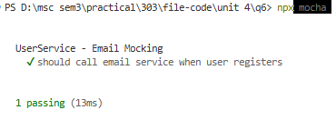
Question 7 — Testing a Task Application
Write an Express.js Task application with POST /tasks and GET /tasks routes. Write a complete Mocha and Chai test suite to verify task creation, retrieving tasks, invalid task data, and the correct HTTP status codes. Use setup and teardown to maintain clean test data.
Hint:
- Create a task with title and completed.
- POST /tasks should return 201.
- GET /tasks should return 200.
- Reject a task without a title using 400.
- Use beforeEach() to reset the task array.
- Use Supertest to test the Express routes.
CODE:
App.js
const express = require("express");
const app = express();
app.use(express.json());
let tasks = [];
// POST /tasks
app.post("/tasks", (req, res) => {
const { title, completed } = req.body;
if (!title) {
return res.status(400).json({
message: "Title is required"
});
}
const task = {
id: tasks.length + 1,
title: title,
completed: completed || false
};
tasks.push(task);
res.status(201).json(task);
});
// GET /tasks
app.get("/tasks", (req, res) => {
res.status(200).json(tasks);
});
// Clear tasks for testing
function clearTasks() {
tasks = [];
}
app.clearTasks = clearTasks;
module.exports = app;

Tasks.test.js
const { expect } = require("chai");
const request = require("supertest");
const app = require("../app");
describe("Task Application", function () {
beforeEach(function () {
app.clearTasks();
});
it("should create a new task", async function () {
const response = await request(app).post("/tasks").send({
title: "Learn Node.js",
completed: false,
});
expect(response.status).to.equal(201);
expect(response.body.title).to.equal("Learn Node.js");
expect(response.body.completed).to.equal(false);
});
it("should retrieve all tasks", async function () {
await request(app).post("/tasks").send({
title: "Learn Mocha",
completed: false,
});
const response = await request(app).get("/tasks");
expect(response.status).to.equal(200);
expect(response.body).to.be.an("array");
expect(response.body).to.have.lengthOf(1);
});
it("should reject a task without a title", async function () {
const response = await request(app).post("/tasks").send({
completed: false,
});
expect(response.status).to.equal(400);
expect(response.body.message).to.equal("Title is required");
});
});

OUTPUT:
